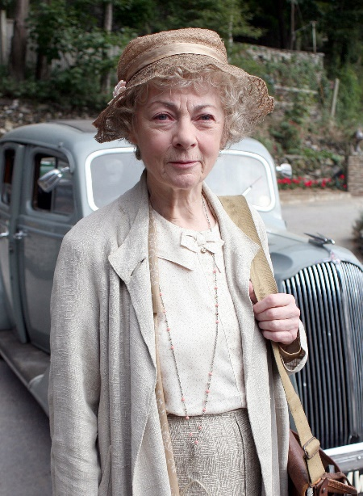

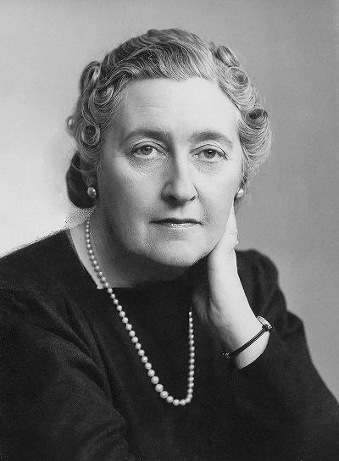

Interview with Agatha Christie and Miss Marple (Lithuanian team)

***For Agatha***

*-We have an interesting task for you to do in the first place. Could you introduce to us another guest today - miss Marple?*

Yes...Firstly, I would like to tell you the history behind of miss Marple. She is the sort of old lady who would have been rather like some of my step grandmother's Ealing cronies – old ladies whom I have met in so many villages where I have gone to stay as a girl. And she is partly based on my grandmother, as well. Well, what I can say more about dear miss Marple, she has a keen eye and is clever, sweet lady.

**For miss Marple**

-*We would like to give you the same question: could you describe to us your author Agatha Christie?*

Well, she is a writer, and quite successful: her novels are ranked in third place of world’s most published books, behind only the Bible and Shakespeare’s plays. However, it is just detective books, the author herself has a sense of mystery in her life. Her life is as fascinating as her novels. And she is enthusiastic and obstinate, regarding the fact that she started writing detective novels because her sister challenged her.

*-What are the first novels that you, Miss Marple, first appeared in?*

I first appeared in six short stories, but the first full-length novel, was “The Murder at the Vicarage” in 1930.

**For Agatha**

*-Why did you start writing and where did you get your inspiration from?*

First, I started writing because I was bored and needed to occupy myself, also I was home schooled, and writing was a way of expressing myself. I never considered being a writer. It was my sister’s idea to write a detective story. I took inspiration from my travels and archaeology which I started to love on my trip to Egypt with my mother. The inspiration for Hercule Poirot came from my time as a nurse. There were a lot of Belgian refugees and I thought that a former Belgian policemen would be a great detective for my novel. But plots and ideas would come to me at such odd moments, when I am walking along the street, or examining a hat shop...suddenly a splendid idea comes into my head. I made endless notes in dozens of notebooks, jotting down erratic ideas and potential plots and characters as they came to me. I wrote about the world I knew and saw, drawing on the military gentlemen, lords and ladies, spinsters, widows and doctors of her family’s circle of friends and acquaintances.

*-Another question for you, Christie, could tell us about your pseudonym?*

Firstly, detective books are signed by my name, but I did use, indeed, a pen name Mary Westmacott. I chose that, partly because my publishers preferred that I would stick with only crime novels. Funny, but for a long time the public did not know that Mary Westmacott and Agatha Christie are the same person. However, the novel “Absent in the Spring” has satisfied me completely, I had a big desire to write a romantic novel. So, I did.

**For miss Marple**

***-****Miss Marple, you are well known for solving crimes, so could you share with us your secret, what does it help you to notice some details which other detectives do not see?*

Well, when you have seen a lot of things over many years, and like observing the life of my village people, you tend to expect the worst from everyone, I know it is pessimistic, but well, it is the human nature we are talking about. Also, I have met a lot of people, like dear Sir Henry Clithering, an old friend of mine, and he gives me some information about certain details when I get involved in the crime scenes.

*-Now, let’s talk about hobbies. Miss Marple, what do you enjoy doing?*

Well one of my biggest hobbies is knitting, also gardening. And of course, there is nothing to brag about, but I like gossiping, too. Also, I travel quite a lot, you see, I have a lot of friends around England.

**For Agatha**

*-You were also taught to be a singer and pianist. Why didn‘t you choose this path?*

It was because I was too shy to perform in front of people. Although, music was also a way to express myself and my feelings.

*-Where did you get all the information and creativity for your novels, Mrs Christie?*

I took a lot of background information for my books on the trip I went on with my mother in Egypt, where, in fact, I fell in love with archaeology. Also, during the first World War I was a nurse, so learned all about pharmaceutical drugs, their preparation and uses – including their lethal dosages. My creativity probably came from my mother who was a great storyteller. She would always tell me stories and I would absorb them.

**For miss Marple**

*-What were the difficulties in your path concerning solving crimes?*

Well, the police do not always like how I interfere with their work process. However, sometimes, they are gentle and thankful to my company.

**For Agatha**

*-Let’s talk about Hercule Poirot, Belgian detective who became a lagend in solving crimes, so I must ask, did Hercule Poirot ever meet Miss Marple?*

No, because they are two completely different people. Poirot, a complete egoist, would not like being taught his business or having suggestions made to him by an elderly spinster lady. And they couldn’t solve crimes together because of that.

*-And why does Poirot speak in third person?*

I often portrayed Poirot as referring to himself in the third person, as a way of depicting his self-grandeur.

**Miss Marple**

*-What did you do for a living if I could ask?*

I have never worked for a living; however, I did get an education which helps me doing my hobbie. I grew up in a cathedral close and studied at an Italian finishing school. Throughout the years, I had some art courses and, studied human anatomy.

**For Agatha**

*-And the last question today, Mrs Christie, have you ever met Sir Arthur Conan Doyle, famous detective books author?*

No, it’s pity, I have never met him, well, I was a little kid when he started his adventures with Sherlock Holmes. Anyway, I am a big fan of his books. When I was five, my mum did not let me learn to read until I would be eight, I taught myself partly thanks to Sherlock Holmes.