Ankaferd Blood Stopper
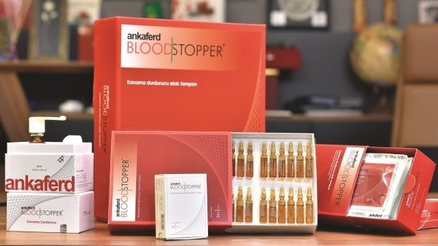
Ankaferd BloodStopper (ABS) is a product claimed to have antihemorrhagic properties. It is used in hospitals and ambulances in Turkey to stop bleeding occurring from external bodily injuries and operations.

Arf invariant in Mathematics
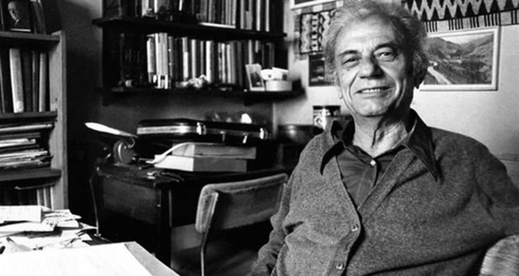
developed from the most notable Mathematicians of the 20th century Cahit Arf.

Behçet's disease
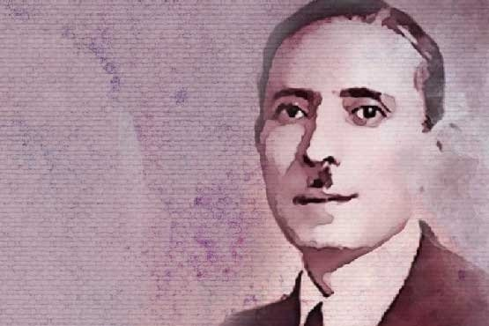
Prof. Dr. Hulusi Behçet was a Turkish dermatalogist and scientist.He described a disease of inflamed blood vessels in 1937, which is named after him as Behçet’s disease. His portrait was depicted on a former Turkish postcard stamp.
Adjustable White Light Generation with Nanocrystals
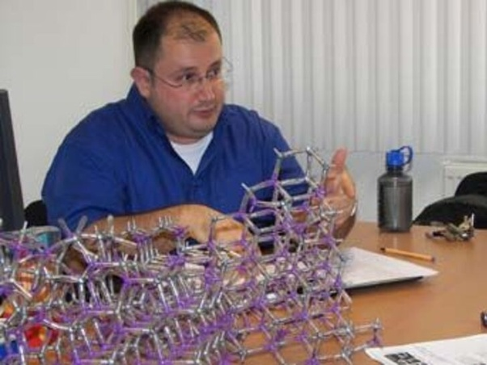
Prof. Dr. Hilmi Volkan Demir and his research group developed a system which is saving 90 % of the energy of LED-lights.
Polar Code - 5G technology
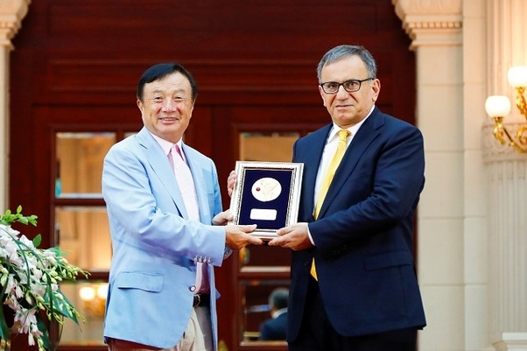
Prof. Dr. Erdal Arikan, a professor at the Turkish Bilkent University is famous as the inventor of the Polar codes, which is one of the fundamentals of the 5G technology and was awarded numerous prizes around the globe and has contributed a significant amount of his knowledge to the Huawei in China for the development of 5G technologies.

DNA repair
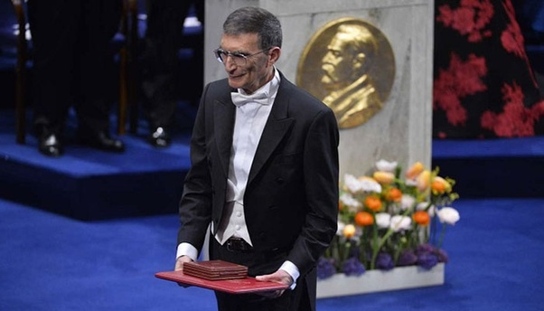
Aziz Sancar was awarded the 2015 Nobel Prize in Chemistry for his mechanistic studies of DNA repair. He was granted Presidential Young Investigator Award from the National Science Foundation in Molecular Biophysics in 1984. Sancar is the second Turkish Nobel Laureate after Orhan Pamuk, who is also an alumnus of Istanbul University.
Unified field theory / Albert Einstein and Behram Kurşunoğlu
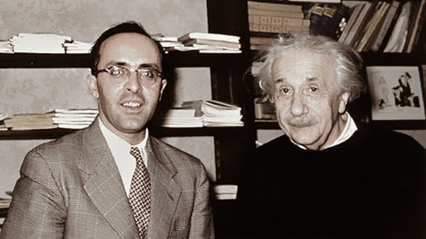
Behram Kurşunoğlu (14 March 1922 – 25 October 2003) was a Turkish physicist and the founder and the director of the Center for Theoretical Studies, University of Miami. He was best known for his works on unified field theory, energy and global issues. Moreover, he participated in the discovery of two different types of neutrinos in late 1950s. During his University of Miami career, he hosted several Nobel Prize laureates, including Paul Dirac, Lars Onsager and Robert Hofstadter. He wrote several books on diverse aspects of physics, the most notable of which is Modern Quantum Theory (1962).

Greatest Neurosurgeon of the 20th century: Prof. Dr. Gazi Yaşargil
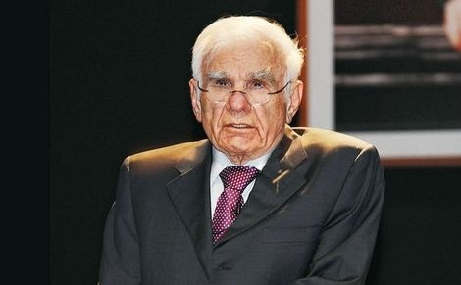
In 1999 he was honored as "Neurosurgery’s Man of the Century 1950–1999" at the Congress of Neurological Surgeons Annual Meeting. He is a founding member of Eurasian Academy. Yaşargil is regarded as one of the greatest neurosurgeons in the modern age. After attending Ankara Atatürk Lisesi and Ankara University in Ankara, Turkey between 1931 and 1943, he went to Germany to study medicine at the Friedrich Schiller University of Jena, Germany. His genius in developing microsurgical techniques for use in cerebrovascular neurosurgery transformed the outcomes of patients with conditions that were previously inoperable

Detection of dead brain cells under fluorescence light
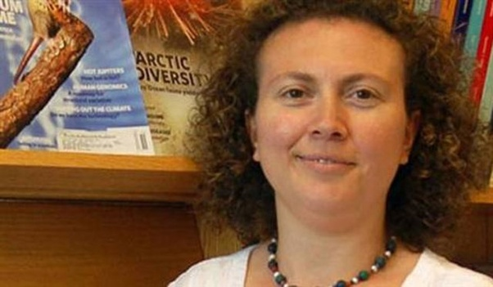
Prof. Dr. Hande Özdinler developed a system to detect dead brain cells under fluorescence and contributed with that to early detection in ALS and all other nerve cell diseases, an important invention in medicine. Dr. Hande Özdinler won the record support of US $ 2.5 million by the American National Health Institute.

ASSAYS FOR DETECTING WDR60 MUTATIONS and Compositions and Methods for Diagnosing, Preventing and Treating Intracranial Aneurysms:
Prof. Dr. Murat Günel
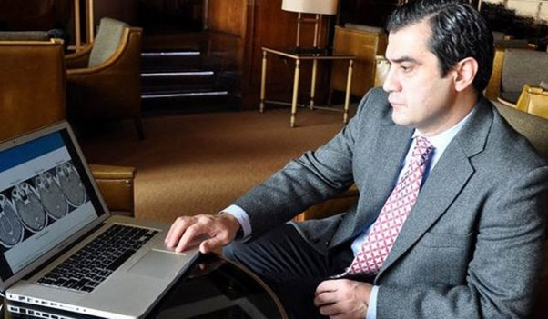
Known as "Genius Turk" in the science world, Yale University, Head of Neurosurgery Department of Neurosurgery and Director of Brain Genetics Program, President of the Turkish American Medical Association. Dr. Murat Günel was named among the top 10 inventors of 2010 by Science, one of the most respected scientific journals in the world.
First image of the black hole:
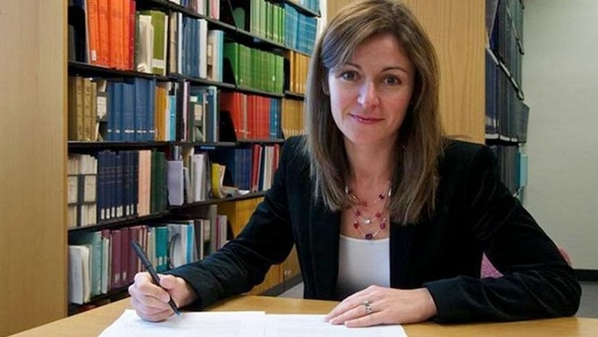
Feryal Özel is a Turkish astrophysicist born in Istanbul, Turkey, specializing in the physics of compact objects and high energy astrophysical phenomena. As of 2019, Özel is a professor at the University of Arizona in Tucson, in the Astronomy Department and Steward Observatory. Özel was one of the important members of the scientist team who has discovered the first image of the black hole.
Noise measurement of light level
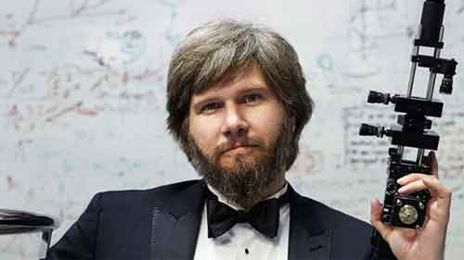
Dr. Mete Atatüre realized a historical invention by successfully performing “noise measurement of light level” which is considered to be impossible to measure. The light obtained a supercoat that was 100 times larger than the wise atom that was measuring by the so-called “compression” method.
Flexible Piezoelectric Devices for Gastrointestinal Motility Sensing
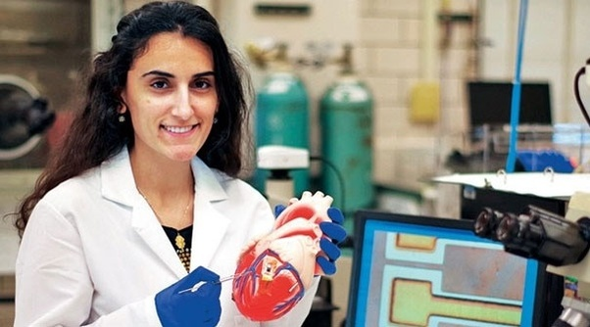
Canan Dağdeviren, who is among the new generation Turkish scientists, is the first Turk to be a member of Harvard University Young Academy. Dağdeviren, a researcher at MIT Media Lab on wearable technology, flexible electronic devices and next-generation circuits, invented the wearable heart chip that can detect skin cancer.

