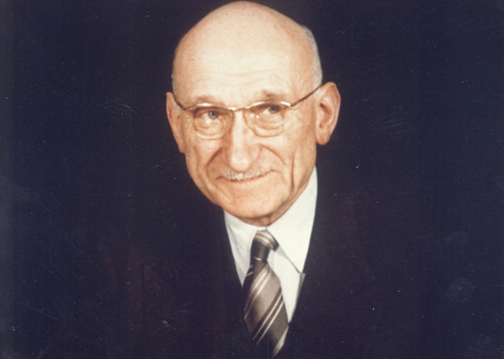
Robert Schuman had a truly European background: born on 29 June 1886 in Luxembourg, his father was a Frenchman. whilst his mother was Luxembourgish. Schuman himself, however, was born a German citizen. Before the war he studied law, economics, political philosophy, theology and statistics at the Universities of Bonn, Munich, Berlin and Strasbourg, and received a law degree with the highest distinction from Strasbourg University.
After graduation, he set up his own law practice in Metz in 1912. Two years later the First World War broke out. Schuman was excused from military service on medical grounds. When the war ended he became active in politics, starting his career in public service as a member of the French Parliament for the Moselle region. When the Second World War began Schuman was a junior minister in the French government. He became active in the French resistance during the war and was taken prisoner. Narrowly escaping deportation to the Dachau concentration camp, he fled to the ‘free’ zone of France. In hiding, with a 100 000 Reichsmark reward on his head, he defied the Germans for the next three years. He declined the invitation of French leader-in-exile de Gaulle to go to London, preferring instead to stay with his compatriots in Nazi-occupied France.
After the war he returned to national politics in a series of toplevel posts: firstly as Minister of Finance, as Prime Minister in 1947, Foreign Minister from 1948-1952 and then as Minister of Justice from 1955-56. He became a key negotiator of major treaties and initiatives such as the Council of Europe, the Marshall Plan and NATO: all initiatives aimed at increased cooperation within the western alliance and to unite Europe.
But what Schuman became most known for is what is now called the 'Schuman Declaration' in which he proposed to Germany and the rest of the European countries to work together towards a merger of their economic interests. He was convinced that when these were tied together, it would render
war 'not merely unthinkable, but materially impossible In a speech delivered on 9 May 1950 Schuman proposed to place Franco-German production of coal and steel under one common High Authority. This organisation would be open to participation to other European countries. This cooperation was to be designed in such a way as to create common interests between European countries which would lead to gradual political integration, a condition for the pacification of relations between them.
His speech did not fall on deaf ears, as German Chancellor Adenauer responded swiftly with a positive reply as did the governments of the Netherlands, Belgium, Italy and Luxembourg.
Within one year, on 18 April 1951, the six founding members signed the Treaty of Paris. It created the European Coal and Steel Community - Europe’s first supranational Community. This ground-breaking organisation paved the way for the European Economic Community and subsequently the European Union, which is still run by the innovative type of European institutions conceived in 1950.
However, his efforts did not stop there. He became a great proponent of further integration through a European Defence Community and in 1958 he became the first President of the predecessor to the current European Parliament.
Because of the significance of his ‘Schuman Declaration’ on 9 May 1950, this day has been designated as ‘Europe Day’.

