WATER CYCLE IN THE NATURE
- Students via https://www.jigsawplanet.com/?rc=play&pid=24229338257b match image
- By working in the group, they try to match the pattern of the image of circulating water in the nature
- Then they answer the questions and the answers are in a completed picture
WORKING LISTS FOR STUDENTS
1. Determine in which aggregate states does water appear in the nature?
2. What is Sublimation?
3. What is condensation?
4. What is evaporation?
5. Is water in all aggregate states equal to the chemical formula?

WORKING LISTS FOR TEACHERS

THE IMAGE OF MATCHED PICTURES
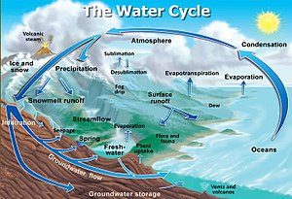

ANSWERS TO QUESTIONS
1. Liquid, gas, solid
2. Water vapor transfer process.
3. Process of transferring water vapor to liquid.
4. The process of water vapor from the surface of the soil.
5. Yes.

