Hungarian HUF

Its origin

The forint (gold forint) was named after the city of Florence, where coins were minted from gold since 1252. The Latin name of this currency was Florentine, which means “originating from Florence”, and the name of the Hungarian Forint (its old name: Florin) origins from it as well.

Hungarian gold coin

The first European ruler who introduced the gold currency in his country was Robert Charles. The Hungarian king used the Hungarian gold coin, which had been minted in Florence since 1325 onwards. St. John the Baptist was engraved with the legend ‘Karolus rex’ on Charles Robert's gold coins. Following the example of the King of Hungary, almost all rulers in Europe introduced the Florentine-type golden coins.
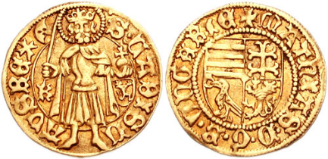
The gold coin of King Matthew

Silver based forint
The silver-based forint was a historic silver-based currency (see as silver currency). It was the primary legal currency of the Habsburg Empire, later the Austro- Hungarian Empire until the introduction of the gold-based currency. Its two main types are the so-called Convention Forint, and then the Austrian Forint. The former was equivalent to 60, the latter to 100 penny.
Convention Forint
In the 18th century, large-scale economic, trade-boosting reforms were introduced in the Habsburg Empire, in which the monetary system was unified. The name of the new currency was Gulden (Florin in Latin, forint in Hungarian), which was introduced by Maria Theresa in 1750. The monarch introduced the twenty-forint money bill; according to which 20 forints had to be milted from silver (about a quarter of a kilogram). The convention forint was also called half-tale and forint lats.
The history of today's Hungarian forint
After World War II, the forint was reintroduced again. This forint was no longer gold based. The chain of the forint is the filler. The forint remained after Hungary joined the European Union, but it will not be in the circulation for a long time. The date of its withdrawal is still uncertain. Anyone who pays with euro in the Hungarian shops will receive the change in HUF.

